Commentary >> Third Party Commentary >> Symposium Papers (CPA Canada Commodity Tax) >> 2010 (Ottawa, September 27-28) >> 8. Hot Topics in Customs

HOT TOPICS IN CUSTOMS
By: Sacco and Zajko, Deloitte

Agenda
Current Trade Environment
Tax Aligned Supply Chain
Customs and Trade Considerations for Key Business Processes
Automating Trade Processes
Voluntary Disclosures and Self-Assessment
Recent Issues in Customs and Trade
AMPS - Update
CBSA Verification Trends and Priorities
Policy Update - Subsequent Proceeds
Case Update

Current Trade Environment
• Companies are cutting costs by shifting even more production offshore to low-cost countries
• Companies are being asked to reduce costs even further- They have squeezed their supply base all they can and must now find additional ways to cut costs
• Tax/Customs departments must work more closely with operations to get into transaction level detail to find new cost reduction opportunities
• Customs function must be a "value-added" function
• When making sourcing/buy decisions, companies must consider their total cost of ownership (TCO) to optimize their cost savings opportunities
• Proper planning requires companies to take a cross-functional approach
• Lack of ability to hire people requires the use of more automation
• Focus on trade facilitation; duty rates are declining
• Customs professionals are increasingly being required to have global knowledge - if not responsibility
• Accounting and tracking GST/VAT globally are becoming a priority
• Increased importance being placed on providing advance data, and electronic data, to customs authorities - trade facilitation with enhanced focus on higher risk transactions (through pre-screening of data)

Tax Aligned Supply Chain ("TASC")
Our experience with leading global traders tells us that they wish to be compliant with the laws and regulations of the countries in which they do business.
• Myth: Compliance slows down the supply chain
• Reality: Risks of non-compliance include:
– Negative impact on delivery times (and revenues)
– Effect on corporate image
– Impediment to taking advantage of special CBSA programs
– Penalties as a deterrent
TASC is the alignment of tax planning with a company's global supply chain strategy.
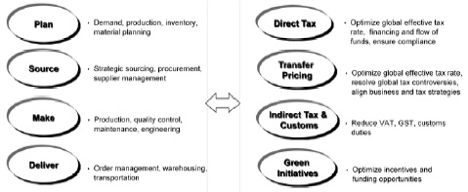
Many low-cost country sourcing decisions are impacted by procurement, logistics, tax and legal perspectives.
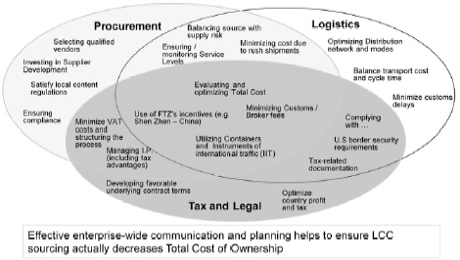
Typically, 80+% of Customs issues are not under the control of the Customs/Import Department
For some, duty recovery is the end-game. Companies need to analyze the underlying cause of errors and prevent future recurrence of the same issues.
Typical factors leading to weaknesses in customs controls:
• Lack of historical data and analysis
• Inadequate documentation of customs processes
• Too much reliance on customs broker
• Lack of management oversight and timely review
• Internal resources (not properly trained or non-existent)
• Poor use of resources (internal and external)
• Poor internal communication and recognition of customs issues
• Lack of effective and efficient automated systems
Companies should strive to minimize the duty impact of various strategic planning decisions, including those related to changes in the supply chain: bundling or unbundling of various pricing/cost components, and sourcing decisions.
• Traditional customs and trade compliance issues permeate the full supply chain
• Crucial to integrate tax opportunities into the business reorganization
• Cost-savings and planning opportunities are also present in each stage
• Addressing duty and tax later can lead to costly rework of systems if valuable planning opportunities have become impractical to implement
• Holistic approach to optimizing customs and trade management throughout the supply chain
• Once tax-aligned changes are decided, they need to be reflected in the ERP systems to meet local statutory and regulatory compliance requirements and to withstand future regulatory audits
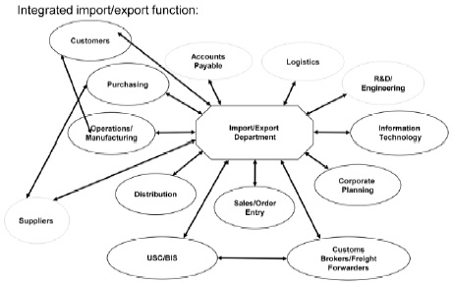

Customs and Trade Considerations for Key Business Processes
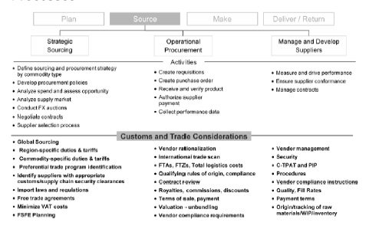

Automating Trade Processes
Business Drivers:
• Relentless pressure to reduce costs
• Tougher sourcing decisions
• Pursuit of revenue growth through new products and new markets
• Managing global complexity
• Preserving brand equity
– Reduce risks of fines, penalties and bad press
– Maintain reputation with enforcement agencies Regulatory drivers
• September 11 and security concerns
• New border admissibility programs
– 10 + 2.ACI
• Importer/exporter self assessment focus on internal controls
• Flurry of activity in free trade agreements
• Export controls and trade sanctions
• Advanced Commercial Information - Security Profiling
– Will apply to all modes of transport (not only marine traffic)
– Data transmission for highway mode carriers to start October 31, 2010 (was delayed due to errors identified in testing of web portal); will be mandatory 1 year after CBSA web portal is available;
– After the first 12 months, there will be a 6-month period of informed compliance, and AMPS wEII apply thereafter
– Requires high level of data coordination by importers
– By Spring 2012, importers will be transmitted "importer data" in the marine mode
• Importer Admissibility Data & US - "10 + 2" Importer Security Filing
– US began enforcing 10 + 2 on January 26, 2010
• 10 data elements must be transmitted to US Customs 24 hours before the lading of ocean containers at the foreign ports
• 2 remaining data elements with 24 hours of arrival
– Canadian importers transhipping through US will need to comply
– Estimated cost to US importers - $20 billion
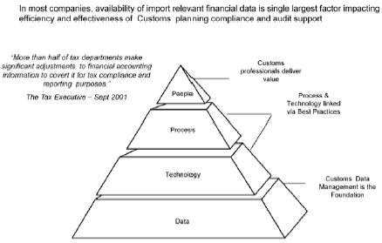
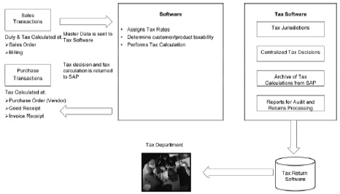
Touch points:
• Capture all tax data elements, structures, attributes, controls and process requirements that are incorporated into the ERP project to support, automate, and enhance tax and regulatory compliance for alJ the ERP modules that are in scope
• Identify and address all Customs and tax audit requirements and electronic record retention needs for all types and jurisdictions
• Identify, review, and capture all Customs and tax accounting and planning opportunities
• Ensure future Customs and tax business requirements are considered
• Communicate Customs tax touch points with other business teams to understand potential impacts caused by import dependencies
• Evaluate tax technology Oracle, SAP and lbolt-onh software packages:
– Sabrix; Vertex; TaxWare...

Voluntary Disclosures and Self-Assessment
Benefits to importer-initiated review - re-assessment policy
• Prospective correction only, provided certain criteria are met
• If prior reason-to-believe for issue indentified, consider voluntary disclosure
– Potential waiver of penalties
– Non-dutiable transactions - potential waiver of interest on GST
Questions to Ask Yourself:
• Is customs compliance a priority within your firm?
• Is your firm well-positioned to avoid penalities?
• Do tax and customs personnel interface on a regular basis?
• Has your company performed an internal audit of customs and indirect tax in the last two years?
• Does your firm know how much it pays in customs duties globally on an annual basis?

Recent Issues in Customs and Trade

CBSA-April 1, 2010 - New Organizational Structure
Purpose
A new management Model that includes:
• Streamlined decision making processes
• Clear accountabilities and roles and responsibilities
• Simplified administrative management
• Vision for the border of the future
• New brand / unifying organizational culture
Key Components
• Programs Branch - Organized based on pre-border, at the border and post-border phases
• Operations Branch - Supports regional delivery of programs and policies and ensures consistent applications across Canada
• Technology Branch - dedicated to planning, development and delivery of IT services
• Recourse Directorate - Reports directly to the President

Additional Trade Sanctions - Iran
• Additional sanctions against Iran imposed under Special Economic Measures Act (SEMA); Regulations in force July 22, 2010
– Iran continues to violate its international obligations by ignoring successive UN Security Council resolutions to cooperate fully with the International Atomic Energy Agency (IAEA) and suspend its enrichment-related activities
– Follows similar action by US and EU
– Severely restricts financial services, investments, technology and trade
– Affects the oil & gas sector as it prohibits export of any goods used in refining oil and gas, or any investment in Iranian oil & gas sector
– CBSA have been enforcing the rules as strict gatekeepers
– Potential for strict penalties and other enforcement action if prohibited goods are exported to Iran
– Regulations to provide for permit to export, at discretion of Minister

Trade Facilitation
Department of Finance - Tariff Relief Initiative
Economic Action Plan
• Canada's response to global recession
• Comprehensive stimulus package to boost Canadian economy:
• Three step plan to assist Canadian business with:
– Reducing production costs
– Enhancing productivity
– Encouraging investment
– Making Canadian exports more competitive in the global marketplace
Three Step Plan;
1. January 2009 Federal Budget
• Elimination of $88 million in annual duties on a wide range of machinery and equipment
2. March 2010 Federal Budget
• $300 million in additional annual duty savings for manufacturing inputs on 1541 tariff items & includes schedule for staged reductions for 381 additional items
– Goods used in the production of other goods
– Eliminating tariff will reduce production costs for Canadian industry
– Requests for eliminating tariffs to enhance competitiveness
3. Future consultations for additional relief - finished goods?

Current Status and What's Next:
Canada is on its way to becoming the first G20 country moving towards a "tariff free zone for manufacturers"
• Importance of correct tariff classification
• Relief to date is approximately 10% of total annual duties
• Potential for future consultations:
– Finished goods not included in steps 1 or 2 but used in the production of goods or the provision of services
– Agricultural inputs - Protected Industry
– Finished Goods - i.e. Retail or consumer goods
• Factors to consider in requesting relief
– Protection of domestic industry
– Luxury items vs. essential items
– Economic case

Trade Liberalisation
Agreements - 4: | Signing/ln-Force Date:
• Canada - Panama | May 14, 2010
• Canada-Peru FTA | August 1, 2009
• Canada-European Free Trade Association  (Iceland, Liechtenstein, Norway, Switzerland) | July 1, 2009
• Canada-Jordan FTA | June 28, 2009
• Canada-Columbia FTA | November 21, 2008
Negotiations :
• European Union - Comprehensive Economic and Trade Agreement
– 5th round of negotiations in Ottawa in October; 2 more rounds in Brussels and Ottawa during January and April 2011
• Singapore
• Dominican Republic
• Central America 4 (El Salvador, Guatemala, Honduras, Nicaragua)
Canada and the European Union (EU) are negotiating a Comprehensive Economic and Trade Agreement (CETA). There have been four rounds of negotiations to date; the most recent, held in July in Brussels, saw significant progress made in the areas of goods, services, technical barriers to trade, regulatory cooperation, customs and trade facilitation, and various others. Negotiators continue to work on the draft text, which is well developed in most areas, with key substantive areas of difference largely identified. Chief Negotiators have also started to engage on the more challenging issues in the negotiations.
The parties are committed to resisting protectionist pressures in challenging economic times, and are seeking to achieve an ambitious outcome across all negotiating areas. The Government of Canada has made CETA negotiations a priority in its international trade agenda and negotiators continue to move the negotiations as quickly as possible.
The fifth round of negotiations is planned for October in Ottawa, after which Canada and the EU will take stock of progress to date and set out the path going forward. Two further rounds have been scheduled for January and April 2011, in Brussels and Ottawa respectively.
Consultations:
• Canada-Turkey
– Formal exploratory meetings in October 2010
– Government is undertaking public consultation - closing Sept 28, 2010
• Canada-Ukraine
– Launched negotiations in mid-May on a bilateral free trade agreement
– Public consultations have shown broad-based support
– Government is continuing to seek consultations through the International Trade website
• Other Exploratory Discussions:
– Morocco, Korea, India

AMPS Update
• Customs Notice 10-002 (February 26, 2010)
– Changes to AMPS Regime as a result of fundamental review (BCCC)
– The review has taken place since 2006 - objective is to ensure AMPS is fair, consistent, and transparent, as well as easy to administer
– Penalty structure is being collapsed, and penalty amounts will be determined based on categories of risk, and impact or severity (very low to very high)
• Violation of International Obligations or Commitments
• Economic Loss
• Health and Safety
• National Security
• Penalty amounts have changed but processing and contravention codes will remain the same until full implementation and automation in 2011-2012.
• Revised approach will be implemented in phases
Border Commercial Consultative Committee - AMPS Sub-committee
• Phase I (April 2010)
– Changes to penalty amounts and structures
• Elimination of most % of VFD penalties; replaced with graduated or flat amounts
– 30 day delay in escalation of penalty levels (low to medium risk only)
– Updates to legislative references and penalty basis in MPD
– Maintaining guidelines on CBSA website to facilitate updates
– Reinstating regional review committees (RRC)
• RRC to review all penalties in post-release environment before issued
• RRC to review border penalties quarterly based on sampling methodology
• Phase II {October 2010)
– Collapse marking contraventions (from 68 to 1)
– Additional penalties subject to 30 day non-escalation
– Penalty Reduction Agreement comments added to NPA
– System enhancements
• Phase III (2011-2012) - full programming of collapsed contraventions
Border Commercial Consultative Committee - AMPS Sub-committee
Clients can request copies of their own AMPS client contravention history maintained by CBSA. Each client is entitled to two requests for copies per calendar year.

CBSA Verification - Trends
• Increased determination of "reason to believe" {RTB) based on evident and transparent legislative provisions
– (e.g. tariff changes - even at subheading or tariff item levels, valuation -based on payment of a charge to the vendor, even where that charge may not clearly form part of transaction value)
• Issuance of AMPS to the sample transactions, as well as the self-corrections {which are required for past 4 years if RTB is determined)
• Correction requirements with 90 days
– May be required to correct 4 year (RTB) or most recent completed fiscal year plus current year (no RTB);
– Not easy to identify all transactions requiring correction without pulling each transaction (e.g. two products in same HS but moving to 2 different HS codes)
– Blanket procedures can be negotiated but some offices/regions are more stringent than others
The CBSA manages compliance with the tariff, origin, and valuation programs using the following two types of post-release verification processes:
1. Random verifications
2. National priority verifications
Random verifications
Random verifications are non-risked verifications used to:
1. Measure revenue loss;
2. Provide statistically-valid compliance rates; and
3. Identify non-compliance issues that merit attention as national priorities.
National priority verifications
National priorities are determined through a risk-based, evergreen process; i.e., new priorities may be added throughout the fiscal year. National priorities may also be carried over from previous years.
The current national priorities are on the slide.

CBSA Verifications - National Priorities
• Tariff classification
– Furniture parts
– Gloves
– Organic surface agents - soap and other than soap
– Stone vs. articles of stone
– Reclaimed rubber
– Juice products
• Origin verification
– Mattress upholstery
– Electric generators
– Tools, implements, cutlery, spoons and forks, of base metal: and parts
• Valuation
– Light duty automotive goods
The CBSA manages compliance with the tariff, origin, and valuation programs using the following two types of post-release verification processes:
1. Random verifications
2. National priority verifications
Random verifications
Random verifications are non-risked verifications used to:
1. Measure revenue loss;
2. Provide statistically-valid compliance rates; and
3. Identify non-compliance issues that merit attention as national priorities.
National priority verifications
National priorities are determined through a risk-based, evergreen process; i.e., new priorities may be added throughout the fiscal year. National priorities may also be carried over from previous years.
The current national priorities are on the slide.

Policy Update
CBSA Policy - "Subsequent Proceeds" D13-4-13
• Released July 8, 2009 detailing policy on the dutiable status of post importation payments made by importers to foreign vendors
• Aimed squarely at related party importers
• Includes payments for research and development, management and administration, and marketing or promotion payments
• All payments added to the value of imported goods {subject to certain exceptions), whether or not they are in respect of the goods or a condition of their sale
• CBSA definition of management & administrative fees:
– Functions: planning, direction, control, coordination, systems or other functions at a managerial level
– Services for various departments: accounting, financial, legal, electronic data processing, employee relations, management consultation, labour negotiations, and taxation
Possible exceptions to application of policy:
• Management or administrative fees for which an importer has objective and quantifiable information that the payments are established using the arm's length principle and are both rendered and justified for the operation of the business in Canada
• Dividends that meet non-resident Part XIII tax requirements supported by CRA divided payment forms
• Financial instruments, such as the assumption or repayment of debt
• Marketing and promotional fees apportioned based on usage of the service provided for product sold in Canada, supported by objective and quantifiable data
• Payments for research where all costs and risk are born by the Canadian company and ownership of the research and all resulting intangibles, and profits, accrue to the Canadian company.
This policy represents a significant shift in approach by the CBSA
• While it is still too early to predict the full impact of the policy, there's little doubt that Canadian importers will view it as contentious and aggressive
• Our experience has been that CBSA has become more aggressive with respect to the type of information and documentation that they expect, particularly where there is little or no TP documentation
• Given CBSA's statement that it will presume all payments sent by a purchaser to a foreign vendor are dutiable, and challenge the importer to rebut their position, importers are strongly advised to initiate an assessment of these payments in order to determine potential risks and exposures
• Timing of reporting and year-end adjustments
• Increases importance of TP documentation, and specificity of information contained therein

Recent cases
• Cherry Stix Ltd. v President of the Canada Border Services Agency
– Test for transaction value: (1) sale for export: (2) purchaser in Canada; and (3) identifiable price paid or payable
– Original Cherry Stix decision determined that Cherry Stix had an agreement to sell the subject goods to Wal-Mart before it ordered from foreign supplier; therefore, sale from foreign supplier to Cherry Stix couJd not be the transaction value for Customs as Cherry Stix was not a purchaser in Canada
– Mattel: relevant sale is the sale by which title passes to the importer
– No sale for export between Cherry Stix and Wal-Mart as CITT determined that title to the goods transferred after importation
– Therefore, Transaction Value Method not applicable
• Impact:
– TVM is predominant method of valuation but will apply in fewer instances
– Valuation under more complicated methods (e.g. computed or deductive)
– May represent a refund or planning opportunity if in the particular situation, an alternative method would result in lower value (i.e, if TV of identical/similar does not apply)
– Customs valuation will be more complex to determine; consider title transfer
• No appeal filed by CBSA; legislative amendment?
• YM (Sales Inc.) v Minister of international Trade
– Application for judicial review of decision under El PA refusing to amend import permits for textile goods to allow duty exemption under NAFTA Tariff Preferential Level (TPL)
– Goods had originally been imported duty free under NAFTA, based on erroneous certification (blamed broker for bad advice in claiming NAFTA)
– YM was assessed the duties ($1.5M)h and first attempt to amend permits for TPL {for textiles cut and sewn in NAFTA territories from non-originating inputs) was denied solely based on administrative policy to disallow permit amendments that was involuntary (i.e. after a DAS had been issued)
– The matter was referred back to the Minister for consideration of the merits of TPL ; however, the ECNOs (Exporter's Certification of Non-Originating Textile Goods) supporting the claim were dated and flawed
– Minister considered merits and denied request again - importer unable to provide contemporaneous information and documentation supporting TPL requirements
– Minister has discretionary authority to amend permit, and is entitled to request information and documentation to support TPL claim; application dismissed
• C.B. Powell Limited
– Imported bacon bits
– Non-dutiable tariff classification declared
– CBSA assessed dutiable classification on audit
– Importer had not declared NAFTA treatment but goods qualified; and time limit for claiming NAFTA (1 year) had elapsed (3 years had elapsed)
– CBSA processed only tariff classification adjustment; did not process NAFTA claim
– Importer appealed but President of CBSA ruled that there was no determination on tariff treatment and so a re-determination could not be made on appeal
– Importer proceeded by judicial review to Federal Court rather than CITT
– Normal rule: parties proceed to court system after all adequate remedial recourses in the administrative process have been exhausted
– "Non-decisions" and refusals to exercise jurisdiction are decisions that can be appealed to the CITT
– Importer required to appeal to CITT; judicial review premature

View Terms and Conditions and Privacy Policy
Help desk: Mon-Fri, 9am-5pm ET 1-866-256-6842 Contact Us
© 2001-2024, EYEP and/or E&Y LLP and/or CPA Canada. All rights reserved.

